**STANDARD OPERATION PROCEDURE**

TOYOTA STANDARD INFORMATION SYSTEM

**TABLE OF CONTENTS**

**Page**

**1. USER’S MANUAL**

1.1 Access to TS System 3

1.2 System Summary 4

1.3 Input New Request 5

1.4 Update TS Revision 7

1.4.1Automatic 7

1.4.2 Manual 9

1.5 List 11

1.5.1 TS x Supplier 11

1.5.2 Supplier x TS 13

1.6 History 15

1.6.1 TS Number 15

1.6.2 Request 16

1.7 Cover Letter 17

1.8 Logout 19

**CHAPTER 1 USER’S MANUAL**

**1.1 Access to TS System**

1. Open internet browser, **Internet Explorer** or **Mozilla Firefox**.



1. Type: **intranet.toyota.co.id/TSOnline** in the URL address bar.



1. Login with your **TMMIN ID** (no reg.) and **password** (0000 for default).

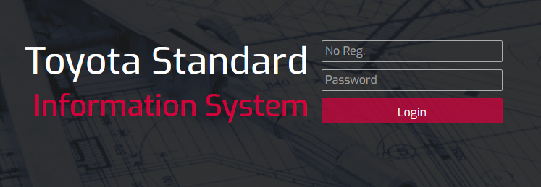

**1.2 System Summary**

1. After logged in, you will arrive on the **Homepage** of the system where you can see statistical summary of the system.

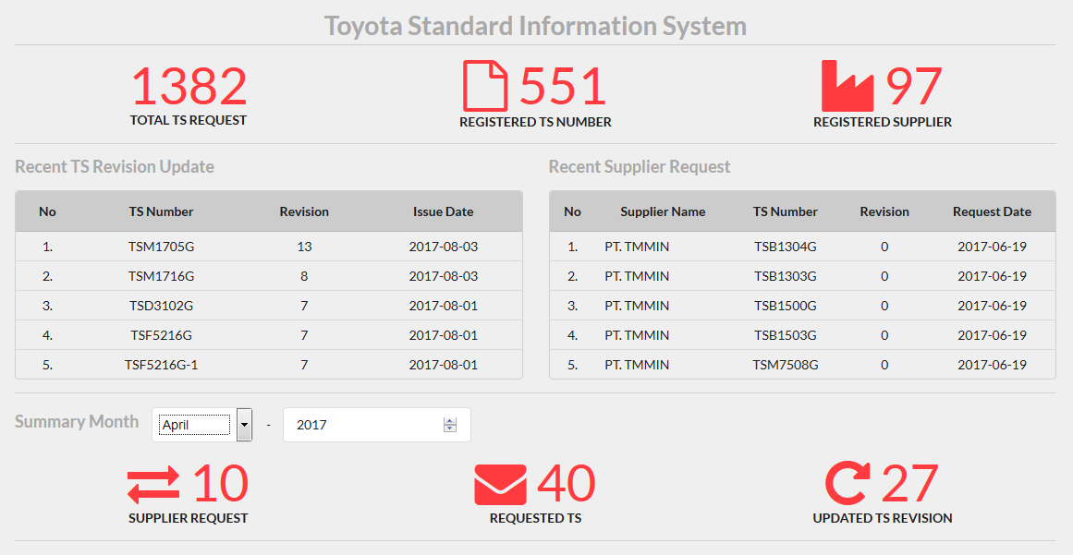

1. Click and choose the month you want to see by clicking the **Month** dropdown.

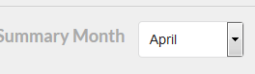

1. Click and type the year you want to see by clicking the **Year** textbox.

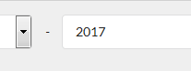

**1.3 Input New Request**

1. Click the “**New Request**” on navigation bar on the top.



1. Input the supplier name in the **Supplier name** textbox or choose from the suggestion.

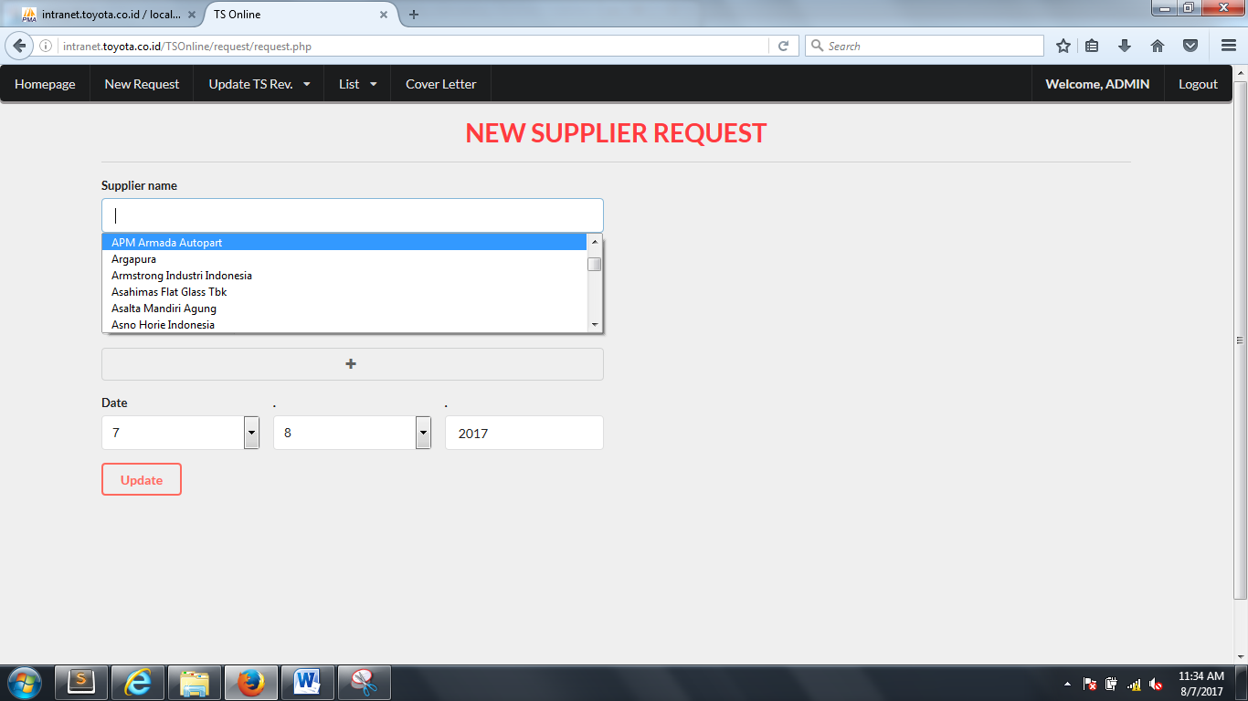

1. Input the TS number, revision, model and part number in the table.

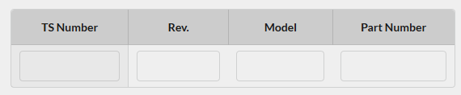

1. Everytime you finish typing in **Rev.** column, **TS Revision Checker** table will appear on the right of the page. The table will check the already owned TS in the supplier.

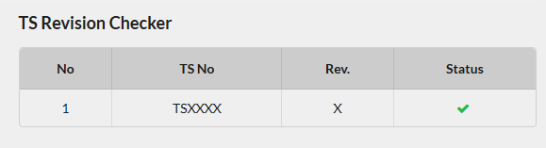

1. Change the **Date** according the request date. The default value is today.

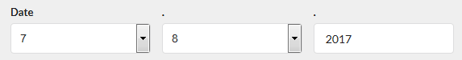

1. Click **Update** button after finish filling the form.

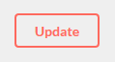

**1.4 Update TS Revision**

**1.4.1 Automatic**

1. Hover the mouse over “**Update TS Rev.**” on the navigation bar on the top.



1. Click the **Auto** option.

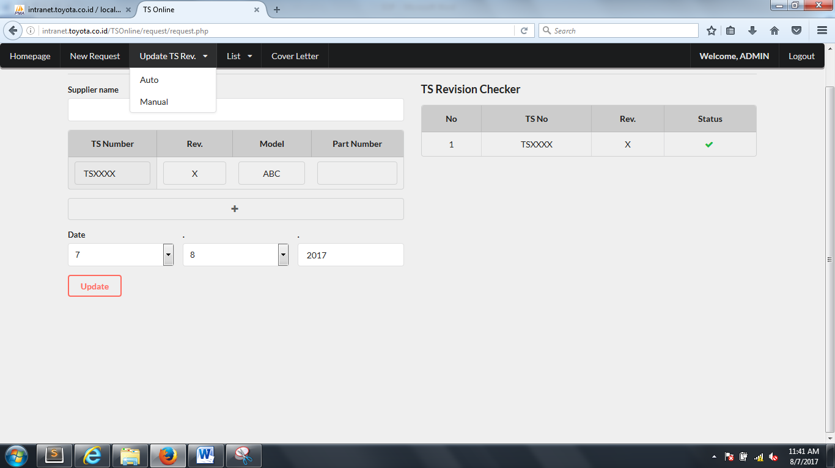

1. Copy the **TS number, revision, and content** from the notification email sent by **TMC** and paste it to the provided textarea. The format should be like this.

･TSxxxx　REV.y　Content

･TSxxxx　REV.y　Content

･TSxxxx　REV.y　Content

*Where x is the TS number and y is the revision.

1. Click **Convert** button.



1. Converted TS result table will appear at the bottom.

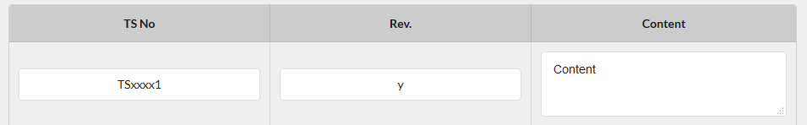

The table will check the database if the inputted TS is already in there or not.

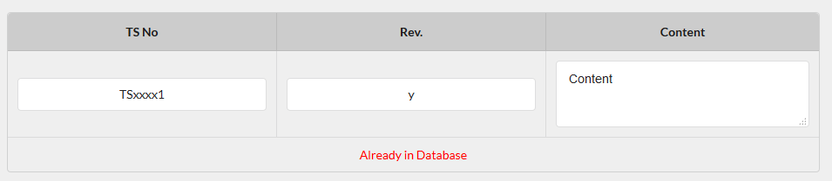

1. Change the **Issue Date** according to the date on the TMC notification email.



1. Click **Submit** button after finish checking the table.



**1.4.2 Manual**

1. Hover the mouse over “**Update TS Rev.**” on the navigation bar on the top.



1. Click **Manual** option.



1. Input the TS number and its revision in the **TS no** and **Revision** text box respectively.

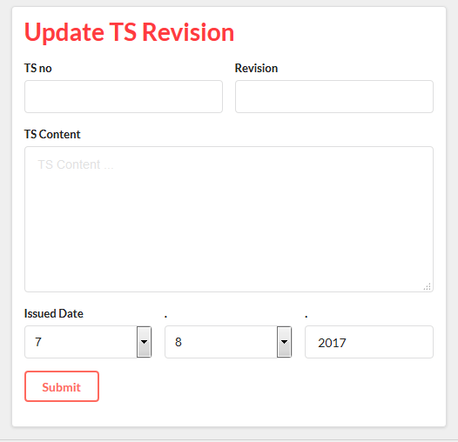

1. The system will check the latest revision of the inputted TS number.

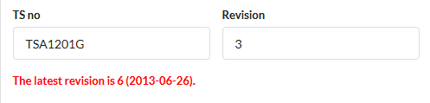

1. Input the TS content in the **TS Content** textarea.



1. Change the **Issue Date** to your desired. The default date is today.



1. Click **Submit** button after finish filling the form.



**1.5 List**

**1.5.1 TS x Supplier**

1. Hover the mouse over “**List**” on the navigation bar on the top.



1. Click **TS x Supplier** option.

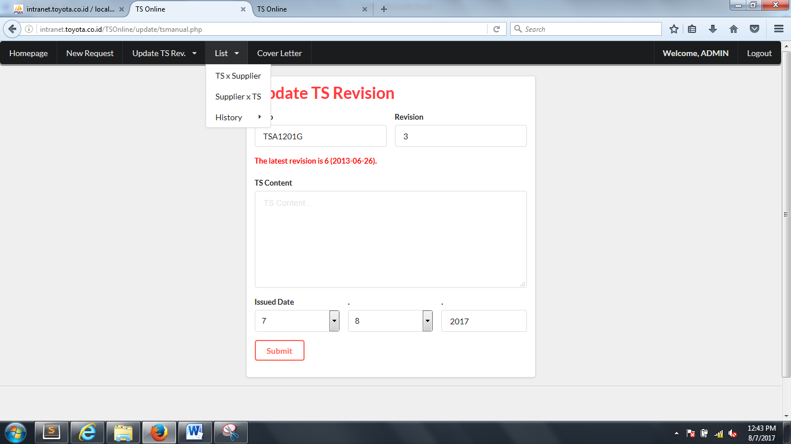

1. You will see list of TS number table. Search your desired TS number in the **TS Number** search box.

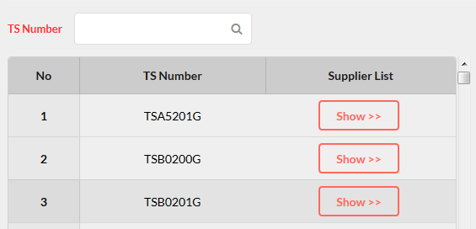

1. Click **Show** button the show the supplier of your desired TS number.



1. Your desired TS number information will appear on the right of the page including the latest revision, date, content, and its supplier.

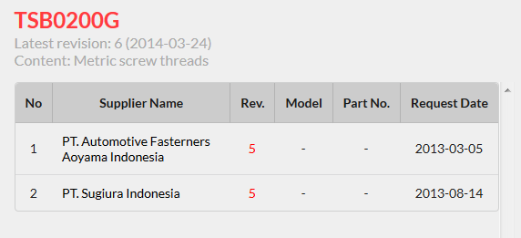

**1.5.2 Supplier x TS**

1. Hover the mouse over “**List**” on the navigation bar on the top.



1. Click **Supplier x TS** option.



1. You will see list of supplier name table. Search your desired supplier in the **Supplier Name** search box.

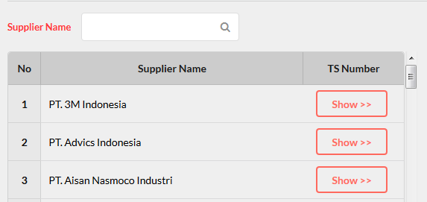

1. Click **Show** button the show the supplier of your desired supplier.



1. Your desired supplier information will appear on the right of the page including their owned TS number and their latest revision.

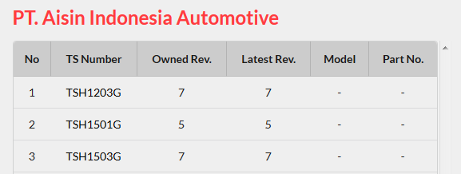

**1.6 History**

**1.6.1 TS Number**

1. Hover the mouse over “**List**” on the navigation bar on the top.



1. Hover the mouse over “**History**” inside “**List**” dropdown.



1. Click **TS** option.

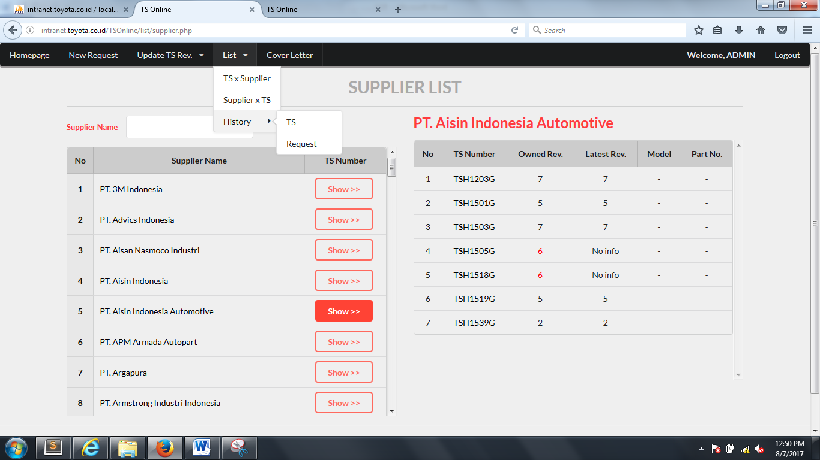

1. You will see list of TS Revision update history. Search your desired TS number or TS content by using the search box on the top right of the list.

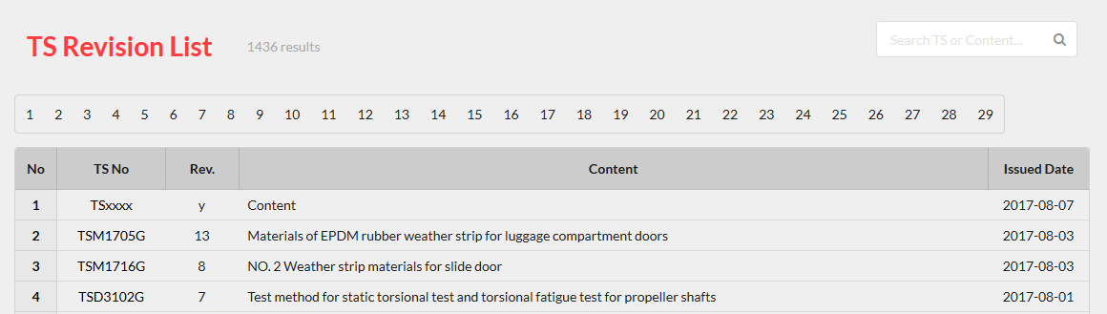

**1.6.2 Request**

1. Hover the mouse over “**List**” on the navigation bar on the top.



1. Hover the mouse over “**History**” inside “**List**” dropdown.



1. Click **Request** option.



1. You will see list of supplier request history. Search your desired supplier, TS number, model or part number by using the search box on the top right of the list.

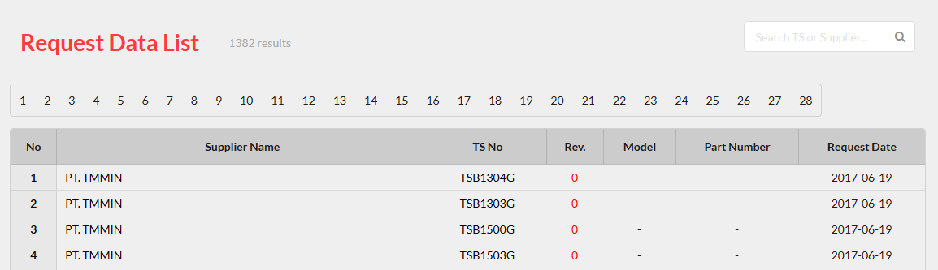

**1.7 Cover Letter**

1. Click the “**Cover Letter**” on the navigation bar on the top.



1. Choose your desired supplier name from the list on the left. You can search supplier name by using the search box on the top of the list.

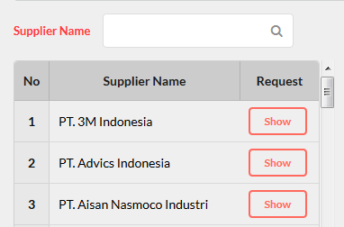

1. Click **Show** button of your chosen supplier name.



1. A list of request from your chosen will appear in the middle of the page.

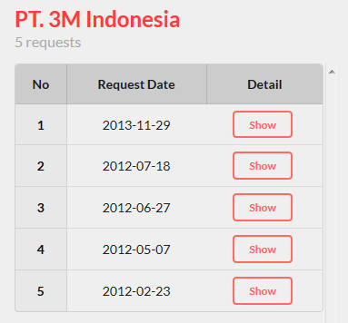

1. Choose your desired request by clicking the **Show** button.



1. The detail of your chosen request will appear on the right of the page.

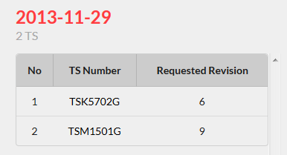

1. Click **Convert** button and you will be directed to cover letter editor.



1. Edit your chosen request detail if necessary.

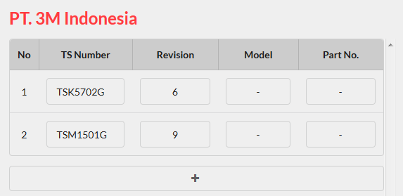

1. Click “**+**” button to add a new row if necessary.



1. Click **Convert** button after finish editing the request detail.



1. Your finished cover letter will appear on the right of the page.

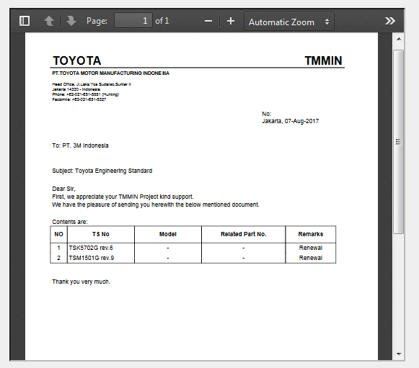

**1.8 Logout**

1. Click **Logout** on the navigation bar on the top right of the page.



1. You will be directed back to **Login** page.